Viewing Applicants on PeopleAdmin
The URL is https://whitmanhr.simplehire.com/hr/login
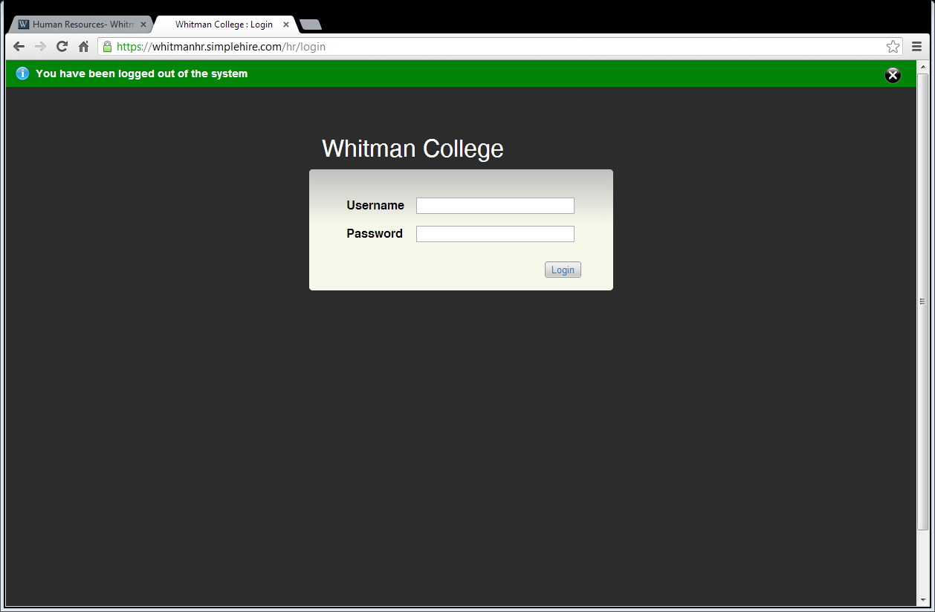
- User name is your Whitman system login without the @whitman.edu
- Password is system password.
To view postings: in the Blue Bar, hover on Postings and click Staff
***The posting may also be listed in your “Watch List”
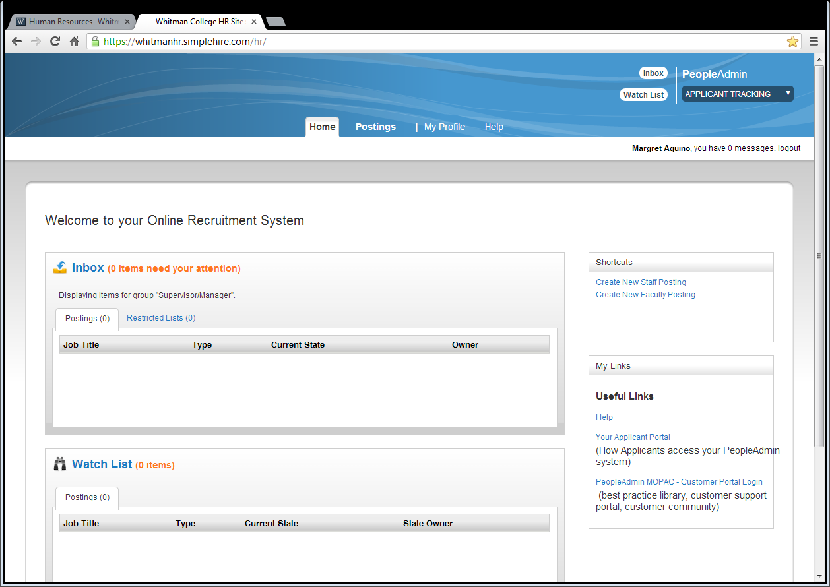

If your active posting does not show up, click More Search Options in the Blue box below Staff Postings. Use the filter options to find your job posting. Click on the title and it will take you to the posting.
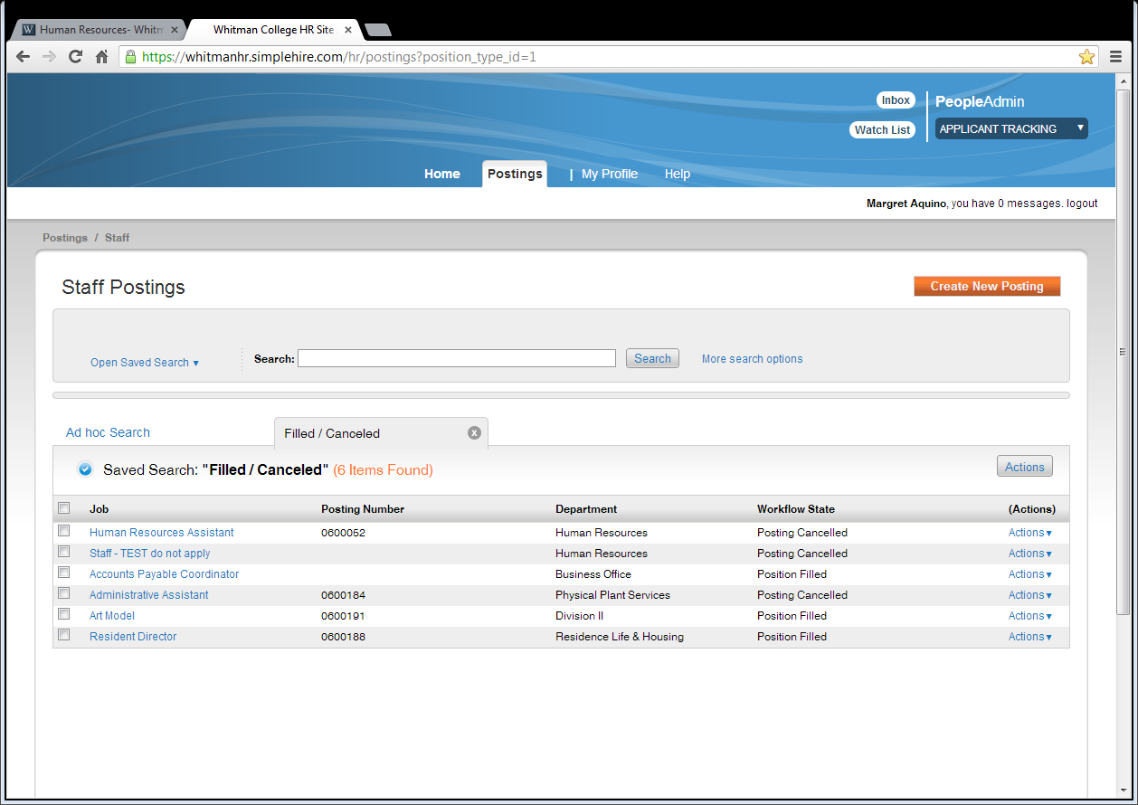
To see Guest User Credentials, scroll down almost to the bottom of the posting on the Summary Tab.
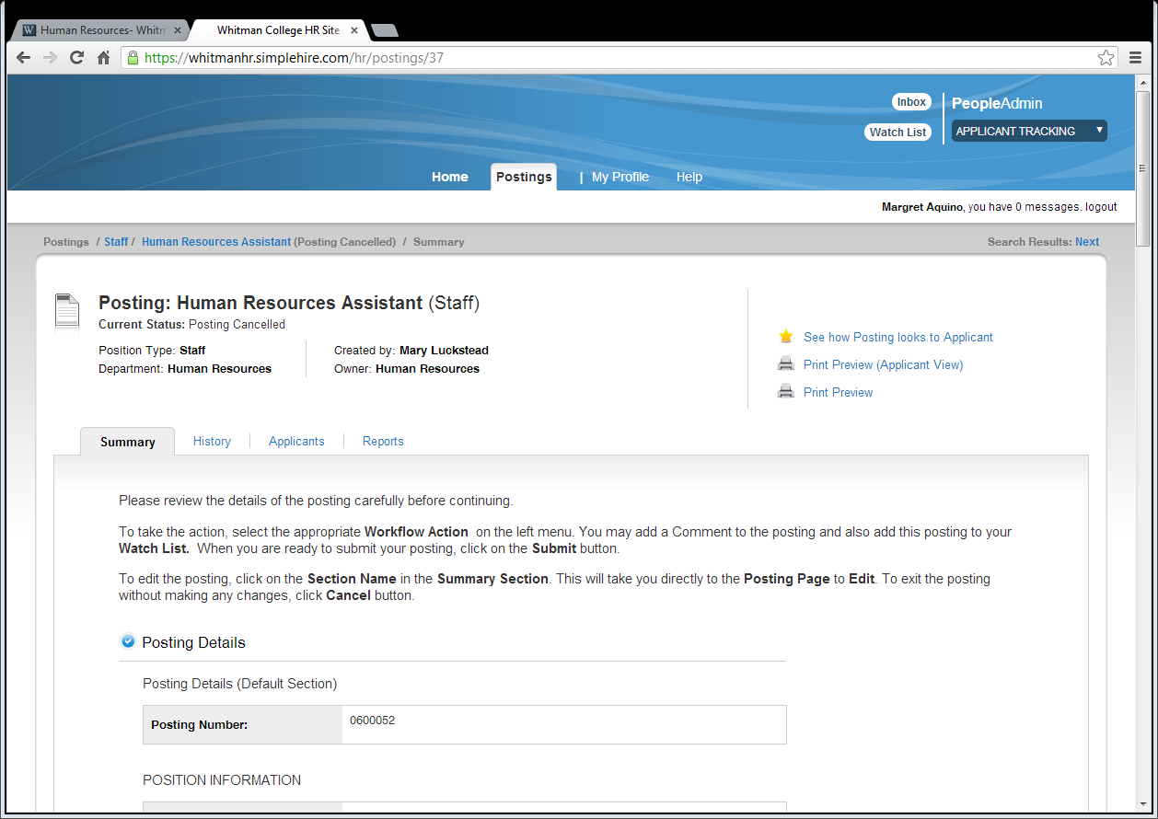

View Applicants: In the white section click the Applicants tab to view a listing
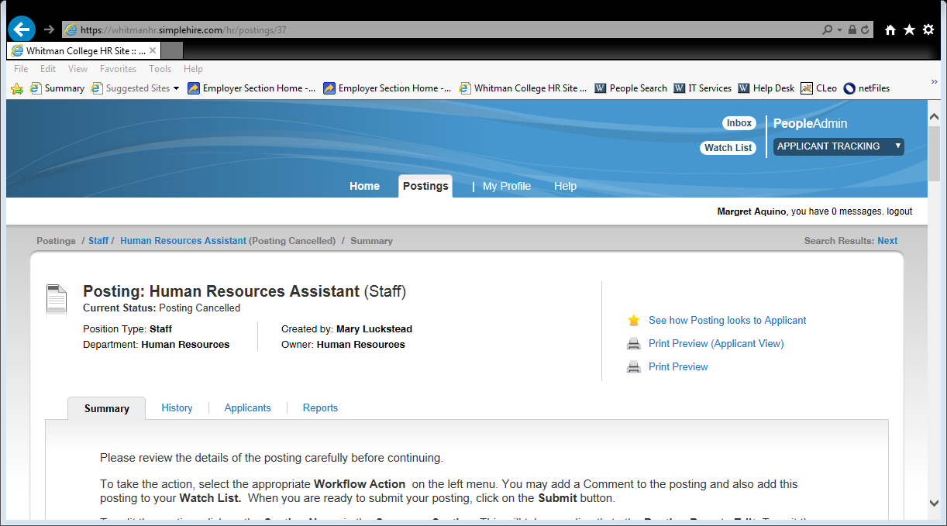
To open an application click the name OR hover over actions and click View Application
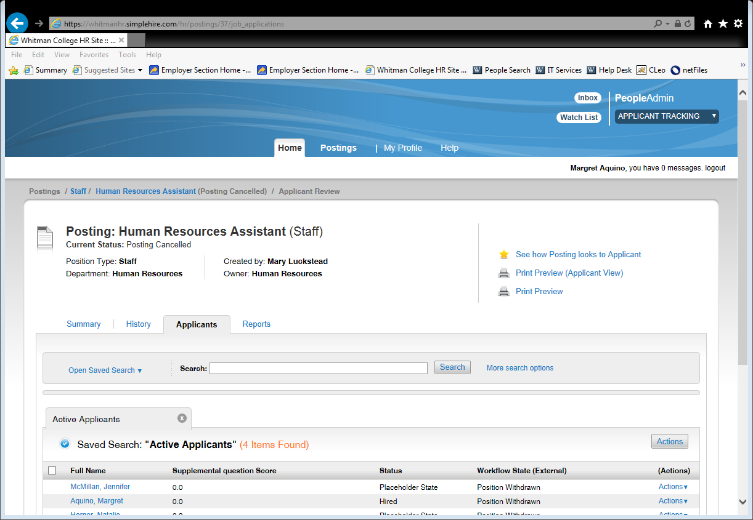
To print the application and associated documents, scroll to the very bottom and click Recreate PDF
To print just associated documents, click on the document name (in the case below Cover Letter_05-31-09_18-55-12CT OR Resume_05-31-09_18-56-35CT
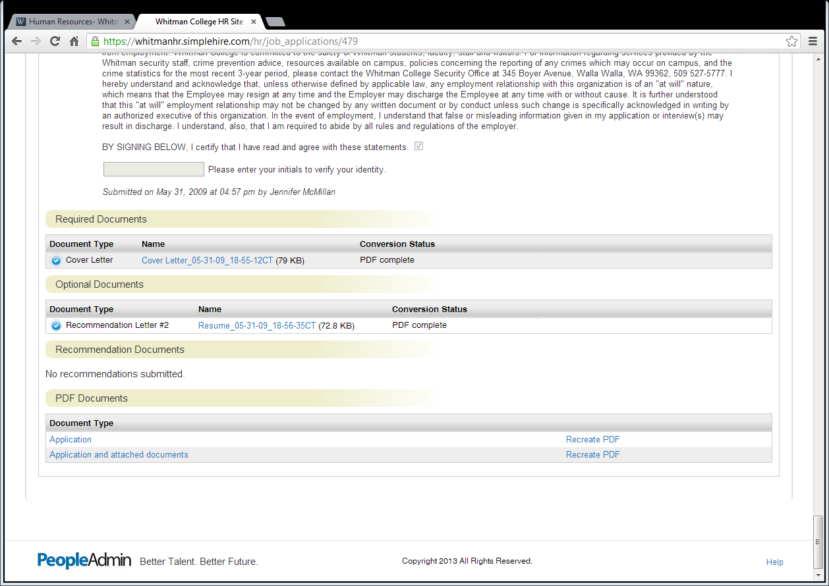
When finished be sure to Logout – right hand side, immediately below blue box.
